Good afternoon Regional Rotary Foundation Coordinators. Trustee Chairman elect Bill Boyd has given me the opportunity to address you today on the importance of the Rotary Peace Centres and I thank him for it is an honour and a privilege to be amongst the movers and shakers of The Rotary Foundation.

Yesterday you shared a joint session with the Rotary Coordinators. I have to congratulate RI President-elect Kalyan and Trustee Chairman-elect Bill for this new initiative because it’s only by working together in a meaningful and productive partnership will you inspire Rotarians to achieve the RI Strategic Goals.

Whether you are an RC or a RRFC the goals you set yourself will be impossible to achieve if there is ongoing conflict in your Zones; but everything is possible if there is PEACE

As a RRFC how will you motivate Rotarians to even consider working on the Foundations six areas of focus if where they live is devastated by conflict, death, mutilation, starvation and the destruction of what make life worth living - HOPE.
Slide series
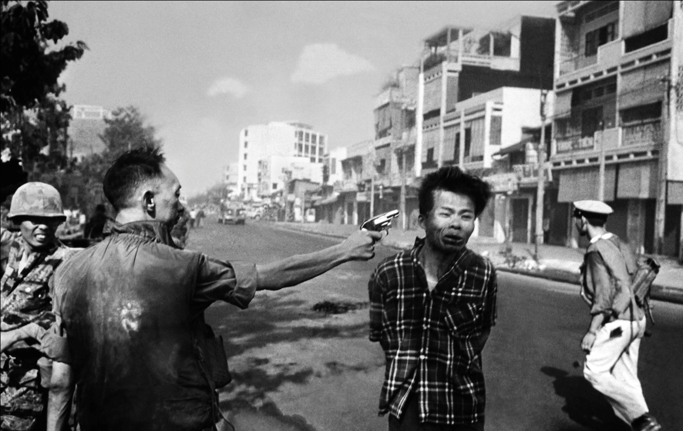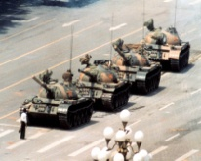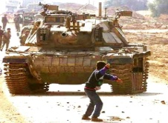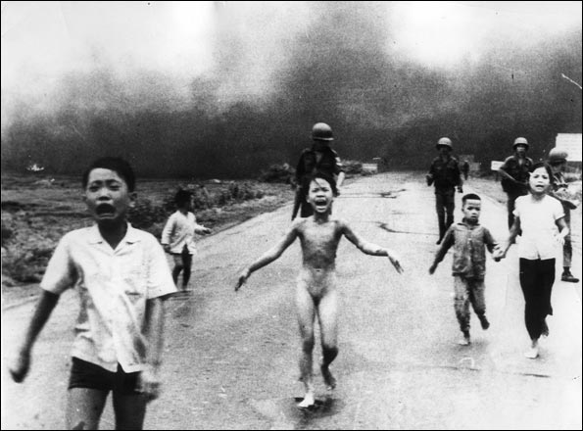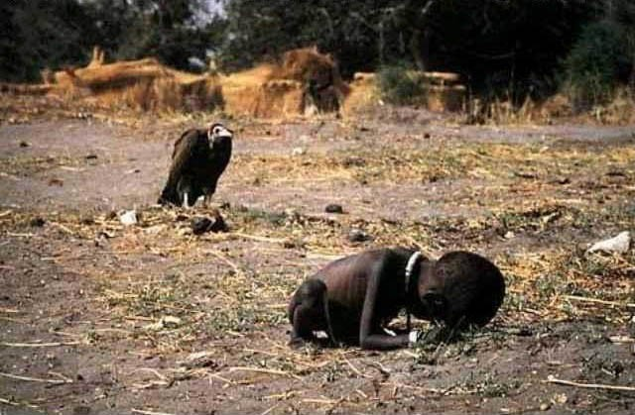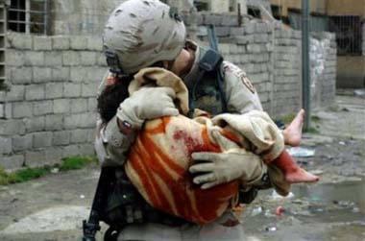

Iconic conflict scenes such as these have unfolded since the death of our founder Paul Harris, who wrote:
“War is always a ghastly blunder ~ even the winners lose”
I am a member of the Rotary Peace Centres Committee, all of whom are dedicated to this program.

We believe the work of the Rotary Peace Centres Program is an example of how the educational and humanitarian programs of RI and TRF come together as a power of good for humankind. We are that close...”finger and thumb”.... to keeping our promise to mankind – The eradication of Polio. The eradication of Polio is the number one goal of Rotary International. It’s no coincidence that the number one educational program of the Rotary Foundation is the Rotary Peace Centres, why?
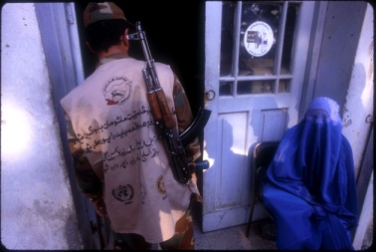
The Trustees know we will not immunise the last child against Polio staring down the barrel of a gun. Herein lies the importance of the interrelationship between the two arms of Rotary International.

I think it’s a sign of my age that the longer I am in Rotary the more admiration I have for previous Rotary Senior Leaders. 1984-86 witnessed the start of our Polio Campaign, the largest Public Health Campaign the world has ever seen. Amazingly we can trace the recognition of the importance of peace to the effectiveness of our programs in that same era. Stan McCaffrey selected the theme “World Understanding and Peace Through Rotary” when he served as RI President in 1981-82. He formed a “New Horizons Committee” and he was so committed to peace he made himself the liaison director! He appointed Cliff Dochterman the Chairman who then focused the committee on the importance of Peace.

There followed numerous suggestions on how Rotary should be involved in the subject of peace. A “Rotary University” had been a dream of many. The vision of a Rotary University dedicated to the study of peace burned brightly for many a year. President Luis Giay in 1996-97 asked the then Vice President Bill Huntley in September 1996 to use “The Build the Future Committee” to develop the theme of a Rotary University.

However, if it was possible to fund such a University, where would you build it in a global organisation of 200 plus countries? In light of this question the committee came up with a proposal to endow a Paul Harris Chair in four Universities around the world. Subsequently, 1996-97 Trustees Chairman RIPP Raja Saboo, appointed a committee named the “Paul Harris Centre for International Studies Committee” chaired, would you believe, by Cliff Dochterman. From these beginnings the Rotary Peace Centres were conceived and have been steered these last 10 years, by dedicated Rotarians such as RI PP Cliff Dochterman and RI PP Chuck Keller.

Achieving peace is not easy. There are so many causes of conflict: mistrust, misunderstanding, preconceived ideas, and intolerance are but a few. So where do you start in developing a program that will address international relations in peace and conflict

Well fellow Rotarians you can be proud of our Rotary Senior Leaders for prior to 9/11 we were the only NGO who had a program of teaching peace and conflict resolution.

However, Rotary cannot deliver this program alone. We are in partnership with six Universities spread throughout the world. Five Universities offer master’s degree related to peace and conflict resolution: University of Bradford England, International Christian University of Japan, Duke/UNC USA, University El Salvador Argentina and University of Brisbane Australia. Chulalongkorn University in Thailand offers a three months professional development certificate in peace and conflict resolution. Each University partner is unique as all educational establishments are. They are the awarding body. They are the faculty that our practitioners wish to study under.

Our Rotary Peace Centres Program is, we believe, unique. It’s a genuine partnership between Rotary and academic establishments around the world. The study program is made up of both academic and practical elements. In both programs, Rotary Peace Fellows are challenged in the classroom, exploring different theories of peace and conflict resolution. And outside the classroom engage in field studies and Applied Field Experience which give the fellows hands-on experience essential to making the aim of the program; building a future of positive Peace

Most unique of all is the way in which the program brings together a group of diverse nationalities and personalities, all working for the same goal: peace. This is the same goal that we Rotarians strive to bring into all of the programs.
In the last year at the University of Bradford alone, the profile of the RPFs was extraordinary.
The ten Fellows came from: Rwanda, Zambia, Japan, NZ, Canada, the USA, Croatia, Palestine and Israel. Each one had a different professional background: a teacher, lawyer, peace educator, economist, marketing executive, accountant, psycho-social worker, journalist, film-maker and a civil servant. That these ten people are but one fifth of one year of students Rotary has put through this program is staggering. With these Fellows going forth to work as the future of the peace field, the value of the Rotary Peace Centres Program speaks for itself.

I have kept in touch with the program since the first site selection visit to Bradford in 1998. My wife Rose and I have been host counsellors to Rotary World Peace Fellows each successive year since the beginning . So who are these remarkable people, what makes them tick? Well shortly you have the privilege to listen to one of them, Amy Kay, Rotary Peace Fellow Alumna.

There are 450 plus RPF Alumni working for peace all over the world. Let me take a few minutes to profile a few of them for you.

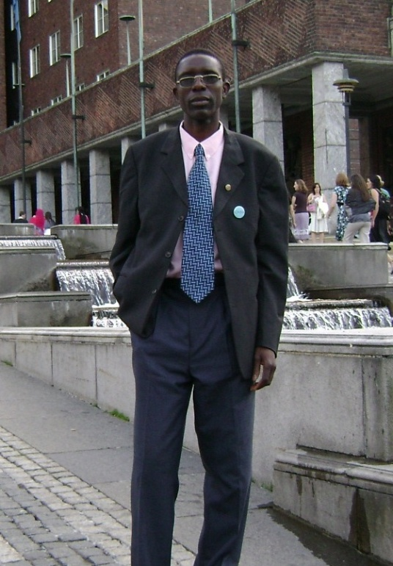
Francis Kabosha
(Paul and Jean Elder Endowed Rotary Peace Fellow)
Chulalongkorn University, January 2007
& University of Bradford, 2008-10

Francis is the first person to complete both the short term certificate program and the full masters program as a Rotary Peace Fellow and is now employed in improving human rights in Africa. He recently accepted a position as a returns, reintegration, & recovery officer for the United Nations Mission in Sudan. During his Applied Field Experience, he studied issues surrounding youth, violence and peace building for the West African Youth Network, Sierra Leone.

After completing the certificate program and before starting his master’s at the University of Bradford, Francis traveled to the Democratic Republic of Congo to work with the UNHCR, government, and NGOs representatives to streamline the repatriation operation for refugees in the Mwange camp along the Zambian border. He was responsible for general administration of refugee affairs in the camp, including protection activities to enhance respect for basic human rights by enforcing the application of national, regional and international conventions.

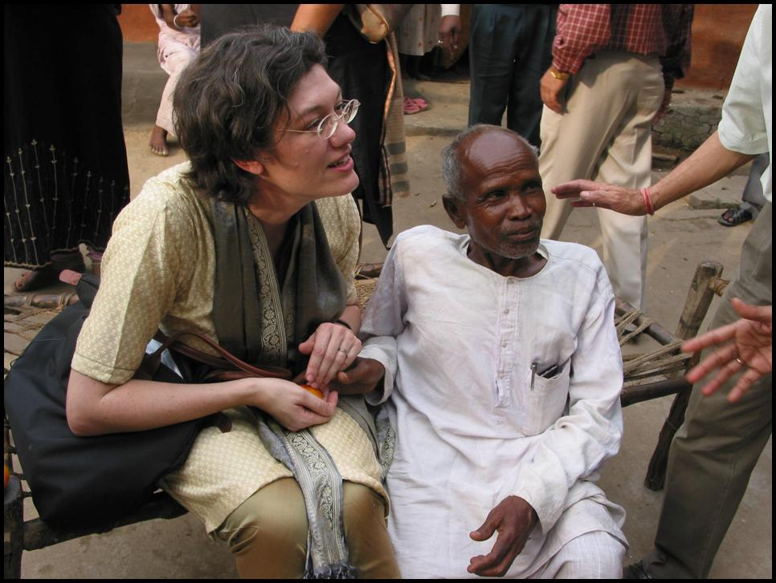
Elisabeth Abeson
International Christian University, 2003-05

Elizabeth is a Coordinator for the Child Rights & Business Principles Initiative, a partnership of UNICEF, Save the Children, and the United Nations Global Compact.
Prior to her fellowship, Elisabeth studied at La Sorbonne, Université de Paris IV, where she gained proficiency in the French language. As a strategist for ibm.com, Elisabeth was a pioneer in the field of e-business globalization, developing and communicating strategies and implementation plans for multinational corporations worldwide. Elisabeth is interested in exploring the possibilities of structural reform within the United Nations and increasing the number of relationships between the United Nations, nongovernmental organizations, and private sector affiliates. After earning her master’s degree in peace and conflict resolution, Elisabeth hopes to revitalize multilateral diplomacy and foster a more ethically sound and sustainable culture.

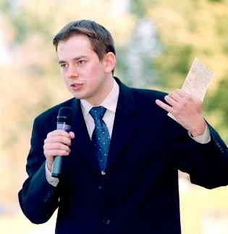Arnoldas Pranckevicius
Institut d’Etudes Politiques
(Sciences Po), 2002-04

Arnoldas is a diplomatic adviser to the President of the European Parliament. He was sponsored by Rotarians in New York but is originally from Lithuania. As part of his undergraduate studies, Arnoldas spent 16 months studying European Security in Geneva and then worked as an intern for U.S. Senator Richard Durbin on the Senate Foreign Relations Committee.

After completing his Rotary Peace Fellowship, he was a policy adviser to the President of Lithuania, before he took his current position at the European Parliament in Brussels, Belgium. Arnoldas has held several positions at the European Parliament, including desk officer for Belarus, Ukraine and Russia and administrator of the Committee on Foreign Affairs. Recently he was promoted to the position of diplomatic adviser to the President of the European Parliament. He advises the President on the Eastern policy for European Union enlargement strategy, and security and defense issues (covering Eastern Europe, Russia, Baltic and Nordic area, Western Balkans, and Turkey),
In 2008 Arnoldas was elected as the president of the Lithuanian Community in Belgium.



The RI President-elect and Trustee Chairman-elect emphasise the importance of this one particular program and ask that you not only promote the program itself but also to seek out individuals and corporate organisations that would be interested in financially supporting our program.

We ask you to take on two responsibilities this year.
#1. Raise the awareness of the program in your Zones by encouraging clubs to become involved in the program. Being involved in the program brings tremendous satisfaction. By identifying and sponsoring a candidate for the fellowship or inviting a RPF to speak at the club or District Conference each Rotary club can be involved in pursuing peace. Encourage clubs to host a RPF for a weekend and invite local organisations and dignitaries to hear their message. As you can see from the profiles I have given, those who will be interested in the fellowship are usually successful in their own chosen careers. Potential Candidates may have graduated in a subject completely unrelated to peace studies but wish to return to academia to gain a qualification/degree in order to apply their skills of peace and conflict resolution.

Successful candidates to the program commit to 15 to 24 months of study having a three months practical Applied Field Experience. Broadly speaking these people are from all walks of life, they are true PEACE Practitioners.

Your second goal is to identify and cultivate potential donors. The program is funded by Rotarians with a target to fully endow the program within the Rotary Foundation Permanent fund of US$95 million by 2015. We are looking for individuals and organisations that have the means to become significant Major Donors to the Peace Program. The next speaker Past Director Paul Netzel Chairman of the Rotary Peace Centres Major Gifts Committee will share some exciting ideas with you on how you can go about fulfilling this goal.

I believe no program or project of Rotary is possible without Peace. Rotary International’s number one priority is the Eradication of Polio. The US$1 billion that Rotary will have donated to defeat Polio and the US$10 billion by other donors will have been wasted if there is conflict. Rotarians will only be defeated in delivering our promise to humankind by conflict.

Paul Harris wrote:
“The way to war is a well-paved highway and the way to peace is still a wilderness”
Fellow Rotarians we have it in our hands to make the Rotary Peace Centres the number one program recognised worldwide for preparing peacemakers. We now have 535 RPF Alumni. 94% of our alumni are in peace related employment. We can dream of the time when one of them is awarded with the Nobel Peace Prize and one will become the first Rotary Peace Fellow to be elected the leader of their country.

Dreams are not just for the young. President-elect Kalyan and Trustee Chairman-elect Bill are working together on the path to peace. Peace is possible, why can’t we dream of a year without conflict, say in 2017 to celebrate the centenary of The Rotary Foundation. Imagine all our Rotary Peace Fellow Alumni working together to encourage governments to stop manufacturing and selling arms, cease supporting conflicts in other countries and work collectively for peace. A Rotary year of Peace 2017!

There were those who said Polio could not be defeated, Rotary will prove those doubters wrong. There are those who say Peace is a pipe dream. We ask you to play your part in proving that Rotary has the vision and the program to make Peace Possible.

The mission of The Rotary Foundation is to enable Rotarians to advance world understanding, goodwill and peace through the improvement of health, the support of education and alleviation of poverty. Yet, none of these objectives are achievable without success in Peace and Conflict Prevention and Resolution.

“The Polio campaign has taught us that vaccines are modern miracles, helping others less fortunate than ourselves is the miracle of Rotary”.

The Peace Centres are our machines for a peaceful future and you are the mechanics that must keep them moving.

Thank you for listening and may I wish you every success in the year ahead

